**FAKE NEWS DETECTION MODELS**

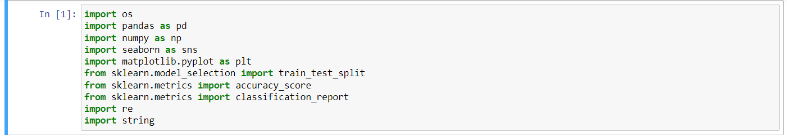

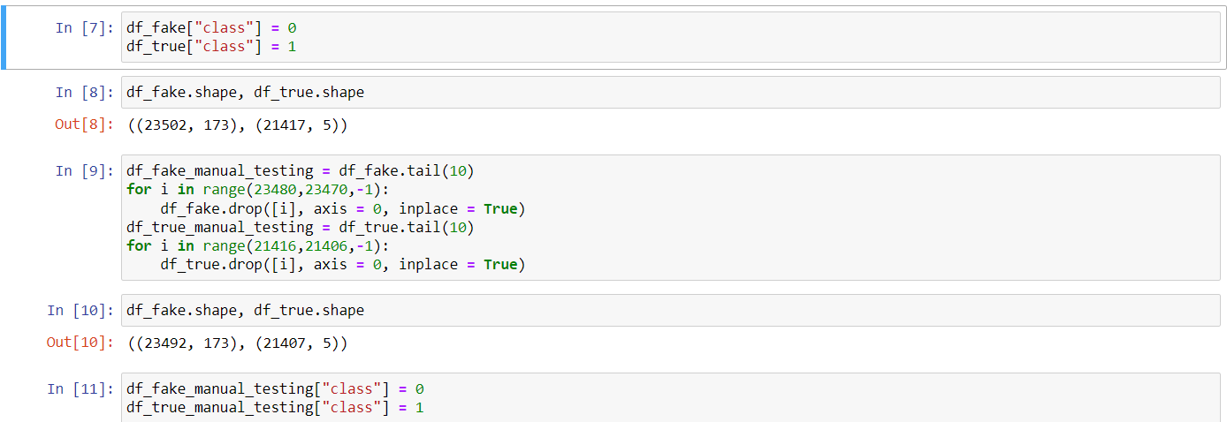

**About the Dataset:**

1: Fake news

0: True news

**PREPROCESSING**

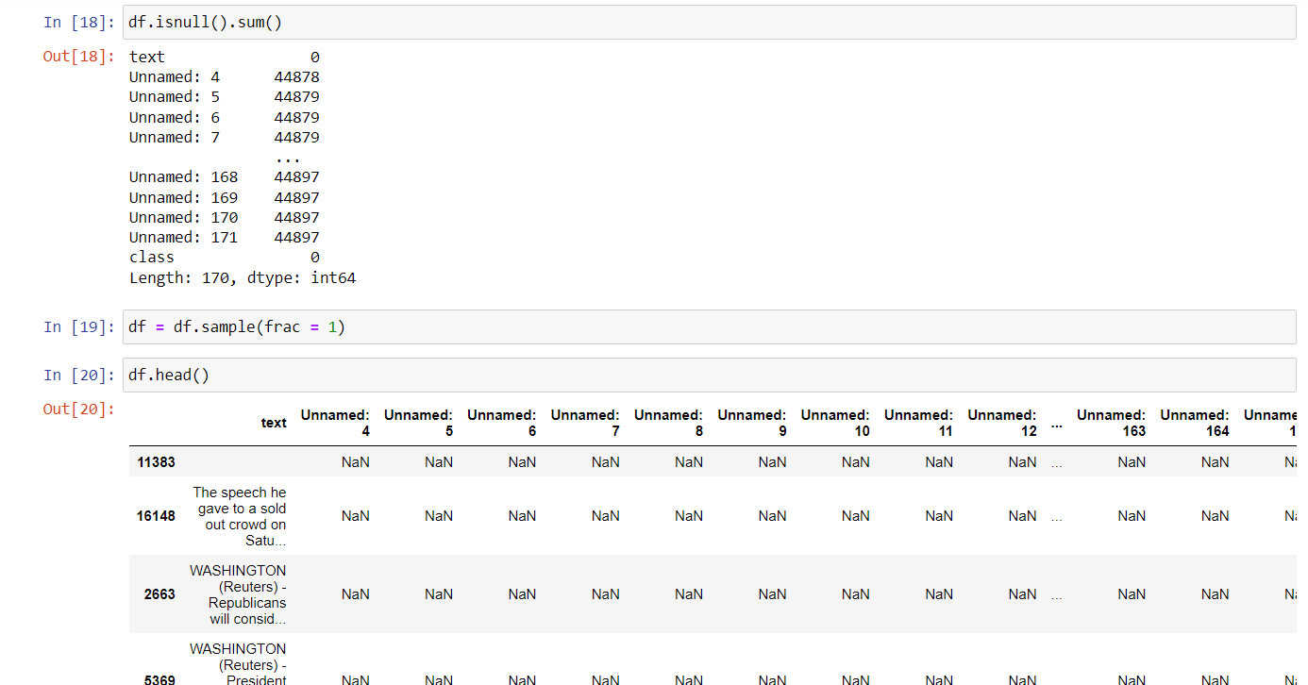

**SPLITTING THE DATASET TO TRAINING AND TESTIONG DATA**



**TRAINING ON MODEL: LOGISTIC REGRESSION**

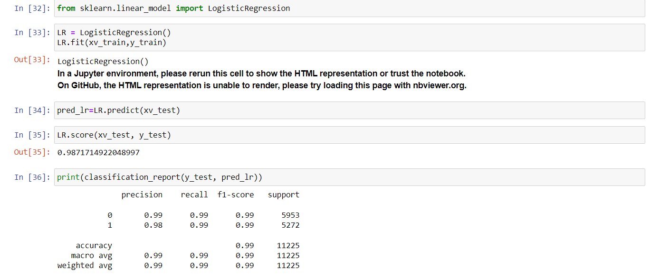

**TRAINING ON MODEL: DECISION TREE**

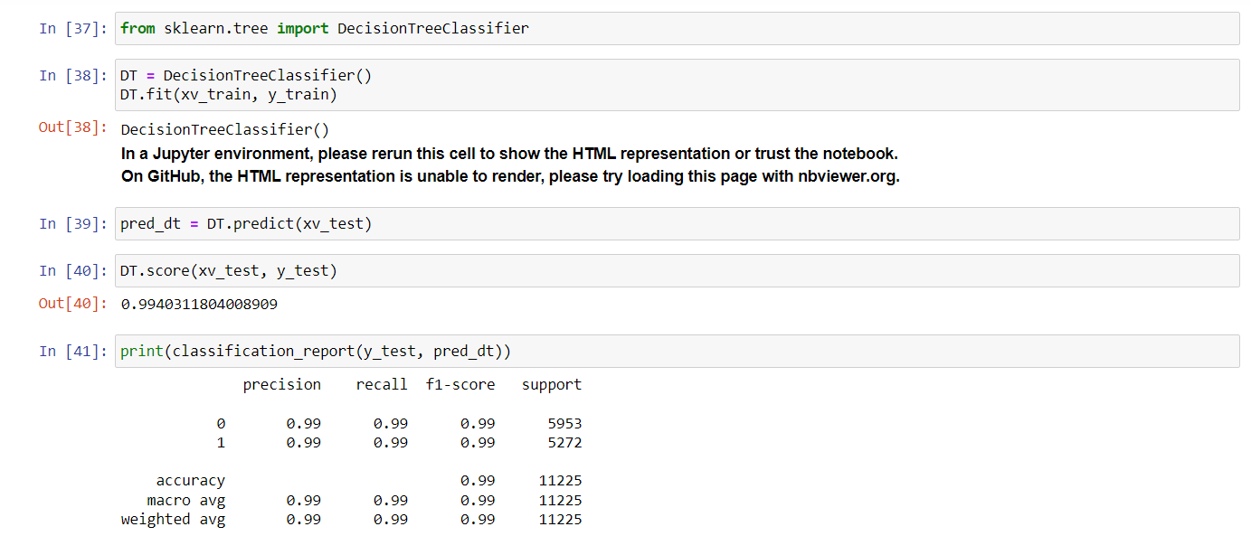

**TRAINING ON MODEL: GRADIENTBOOSTING CLASSIFIER**

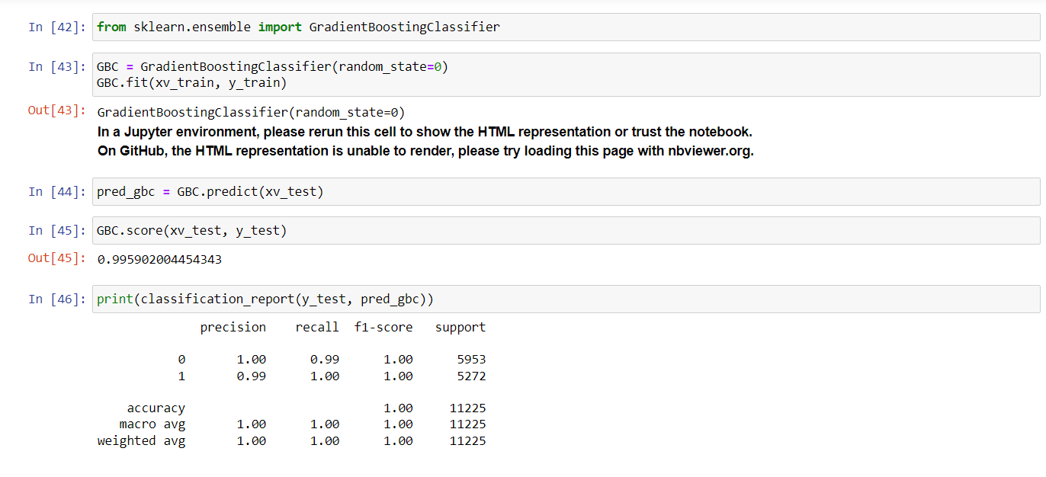

**TRAINING ON MODEL: RANDOM FOREST**

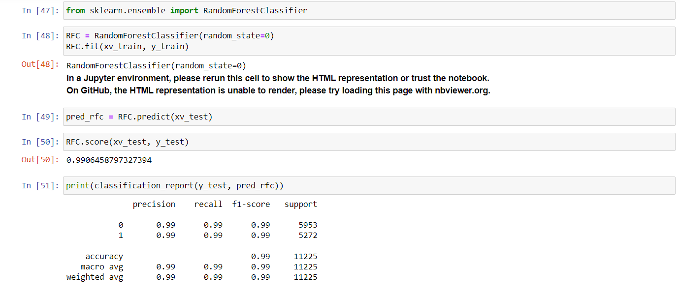

**TESTING**

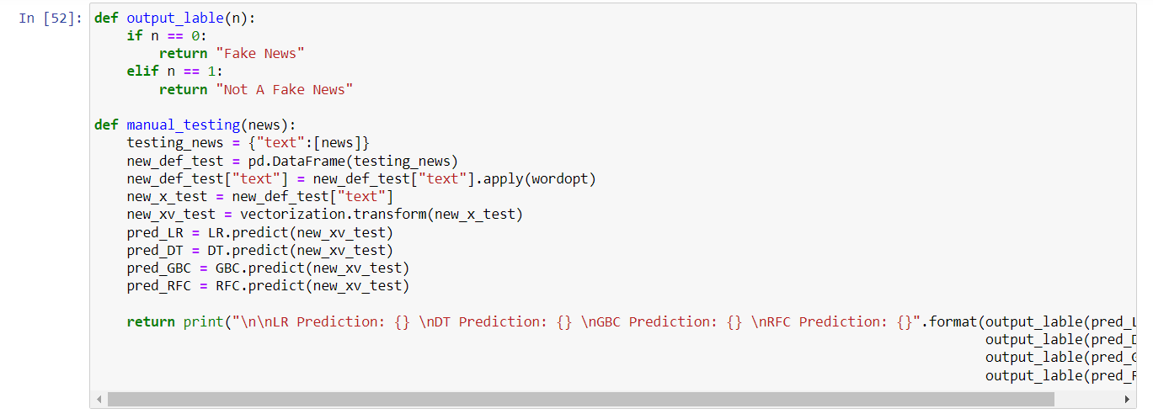

**DETECTION SYSTEM AND OUTPUT**

